Experiment – Elektroskop-Propeller

Material
2 x Papierstrohhalme | 1 x Kunststoff-Strohhalm | 1 x Stecknadel
1 x Universalmuffe

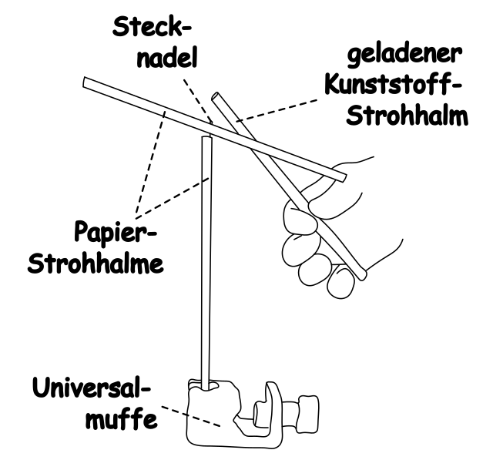
Beschreibung und Durchführung
Baue den Versuch wie in der Abbildung zu sehen auf.

Beschreibe deine Beobachtungen
____________________________________________________________________________________________________________________________________________________________________________________________________________________________________________________________________________

Erkläre deine Beobachtungen
____________________________________________________________________________________________________________________________________________________________________________________________________________________________________________________________________________
____________________________________________________________________________________________________________________________________________________________________________________________________________________________________________________________________________

