Flaschentaucher

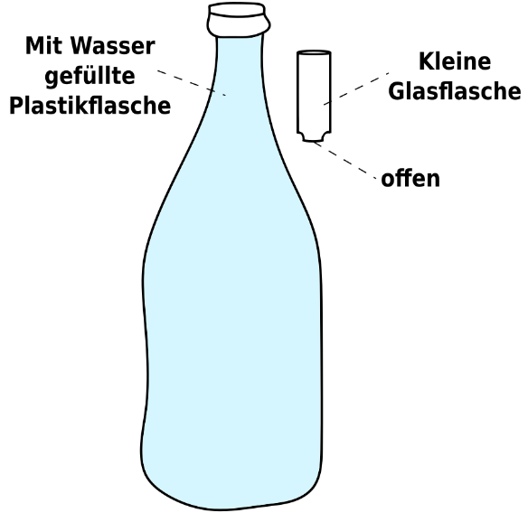

Materialien und Versuchsaufbau
Du benötigst eine vollständig mit Wasser gefüllte Plastikflasche und eine leere kleine Glasflasche.

Durchführung
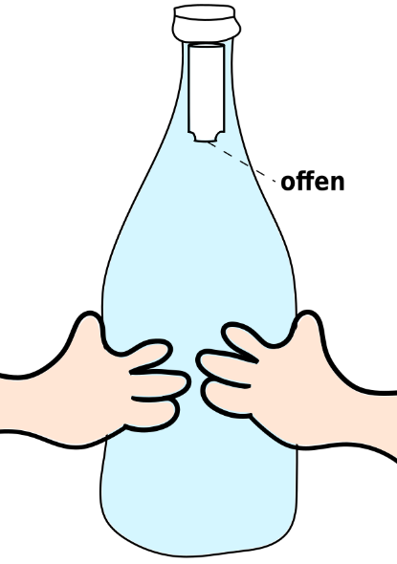

- Führe die kleine Glasflasche mit der offenen Seite nach unten in die große Plastikflasche ein, sodass kein/ kaum Wasser in die kleine Glasflasche eindringt.
- Verschließe die große Plastikflasche sorgfältig.
- Drücke die große Plastikflasche mit beiden Händen kräftig zusammen.

Aufgaben
- Beschreibe und zeichne was du siehst, wenn du die Plastikflasche zusammendrückst.
__________________________________________________________________________________________________________________________________________________________________________________________________________________________________________________________________________________________________________________________________________________________________________________________________________________________
Zeichnungen
- ohne Zusammendrücken b) mit Zusammendrücken

- Erkläre deine Beobachtungen. Wie kommt es dazu?
____________________________________________________________________________________________________________________________________________________________________________________________________________________________________________________________________________________________________________________________________________________________________________________________________________________________________________________________________________________________________________
____________________________________________________________________________________________________________________________________________________________________
______________________________________________________________________________________________________________________________________________________________________________________________________________________________________________________

