Schallkanone __________
Wenn du versuchst eine Kerze auszupusten, presst du gewöhnlich deine Lippen zusammen, sodass die Luft nur durch einen engen Spalt gezielt Richtung Kerze austritt. Das Prinzip verwendet man auch bei einer sogenannten Schallkanone.

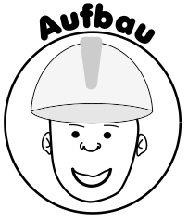
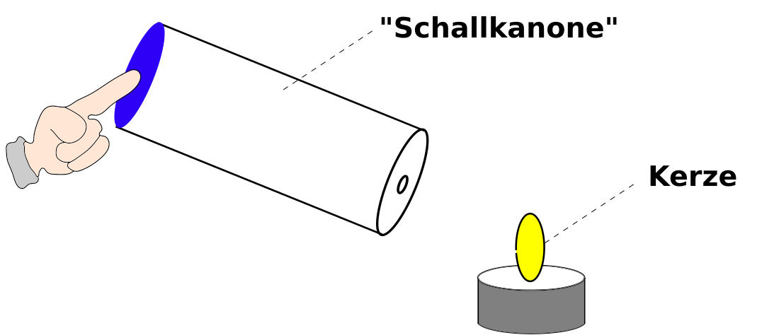

Formuliere die Durchführung:

__________________________________________________________________________
__________________________________________________________________________
__________________________________________________________________________
__________________________________________________________________________
__________________________________________________________________________
__________________________________________________________________________
__________________________________________________________________________
__________________________________________________________________________

Arbeitsauftrag: Erkläre mithilfe der Bilderabfolge, wie man mit einer
Schallkanone die Kerzenflamme “auspusten“ kann.






