 **Schallgeschwindigkeit in Luft** __________

Es gibt einen Trick die Entfernung eines Gewitters grob abzuschätzen. Dazu benötigt man die Geschwindigkeit des Schalls in Luft. Nutze die Ergebnisse des folgenden Experiments, um diese zu bestimmen.



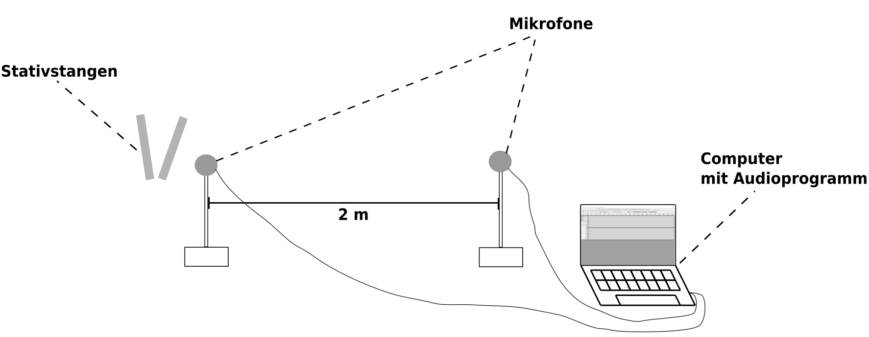



**Formuliere die Durchführung:**

__________________________________________________________________________

__________________________________________________________________________

__________________________________________________________________________

__________________________________________________________________________

__________________________________________________________________________

__________________________________________________________________________

__________________________________________________________________________

__________________________________________________________________________



**Arbeitsauftrag:** Bestimme für die ausgewählten Audiodateien, die

Schallgeschwindigkeit in Luft! Die Zahlen geben die Zeiten

in Sekunden an.

**c)**

|  |  |  |  |  |  |  |  |  |  |  |  |  |  |  |  |  |  |  |  |  |  |  |  |  |  |  |  |  |  |
| --- | --- | --- | --- | --- | --- | --- | --- | --- | --- | --- | --- | --- | --- | --- | --- | --- | --- | --- | --- | --- | --- | --- | --- | --- | --- | --- | --- | --- | --- |
|  |  |  |  |  |  |  |  |  |  |  |  |  |  |  |  |  |  |  |  |  |  |  |  |  |  |  |  |  |  |
|  |  |  |  |  |  |  |  |  |  |  |  |  |  |  |  |  |  |  |  |  |  |  |  |  |  |  |  |  |  |
|  |  |  |  |  |  |  |  |  |  |  |  |  |  |  |  |  |  |  |  |  |  |  |  |  |  |  |  |  |  |
|  |  |  |  |  |  |  |  |  |  |  |  |  |  |  |  |  |  |  |  |  |  |  |  |  |  |  |  |  |  |
|  |  |  |  |  |  |  |  |  |  |  |  |  |  |  |  |  |  |  |  |  |  |  |  |  |  |  |  |  |  |

Bilde den Mittelwert der drei Werte: _____________________________

**a)**

|  |  |  |  |  |  |  |  |  |  |  |  |
| --- | --- | --- | --- | --- | --- | --- | --- | --- | --- | --- | --- |
|  |  |  |  |  |  |  |  |  |  |  |  |
|  |  |  |  |  |  |  |  |  |  |  |  |
|  |  |  |  |  |  |  |  |  |  |  |  |
|  |  |  |  |  |  |  |  |  |  |  |  |
|  |  |  |  |  |  |  |  |  |  |  |  |
|  |  |  |  |  |  |  |  |  |  |  |  |
|  |  |  |  |  |  |  |  |  |  |  |  |

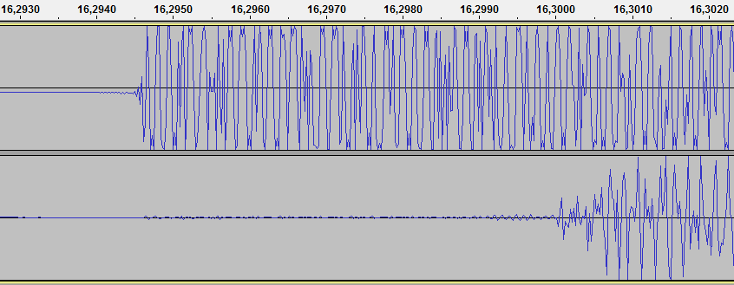

**b)**

|  |  |  |  |  |  |  |  |  |  |  |  |
| --- | --- | --- | --- | --- | --- | --- | --- | --- | --- | --- | --- |
|  |  |  |  |  |  |  |  |  |  |  |  |
|  |  |  |  |  |  |  |  |  |  |  |  |
|  |  |  |  |  |  |  |  |  |  |  |  |
|  |  |  |  |  |  |  |  |  |  |  |  |
|  |  |  |  |  |  |  |  |  |  |  |  |
|  |  |  |  |  |  |  |  |  |  |  |  |
|  |  |  |  |  |  |  |  |  |  |  |  |
|  |  |  |  |  |  |  |  |  |  |  |  |

