 **Schallgeschwindigkeit in Wasser** __________

Du hast bereits die Schallgeschwindigkeit in Luft experimentell bestimmt. In Luft sind die einzelnen „Luftteilchen“ im Durchschnitt weiter voneinander entfernt, als die „Wasserteilchen“ im Wasser. Hat dieses einen Einfluss auf die Schallgeschwindigkeit? Finde es heraus!



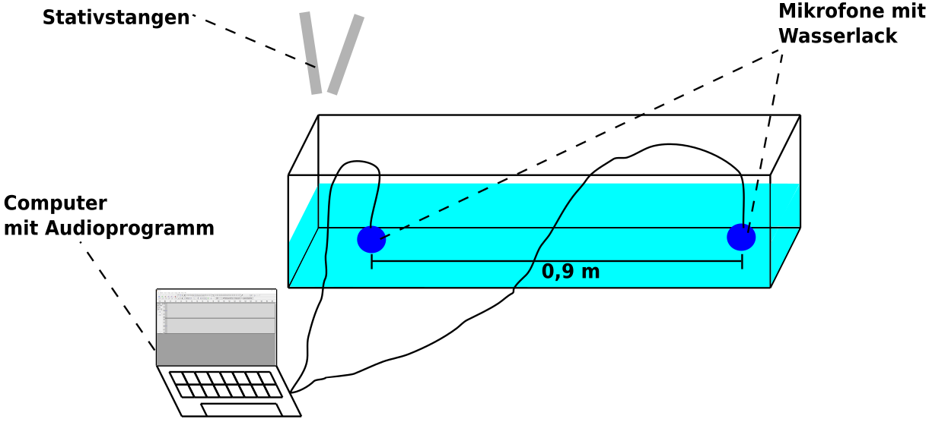



**Formuliere die Durchführung:**

__________________________________________________________________________

__________________________________________________________________________

__________________________________________________________________________

__________________________________________________________________________

__________________________________________________________________________

__________________________________________________________________________

__________________________________________________________________________

__________________________________________________________________________



**Arbeitsauftrag:** Bestimme für die ausgewählten Audiodateien, die

Schallgeschwindigkeit in Wasser! Die Zahlen geben die Zeiten

in Sekunden an.

**c)**

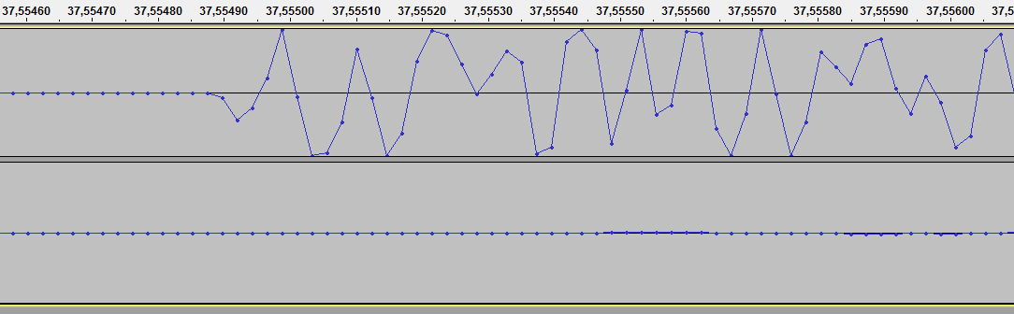

|  |  |  |  |  |  |  |  |  |  |  |  |  |  |  |  |  |  |  |  |  |  |  |  |  |  |  |  |  |  |
| --- | --- | --- | --- | --- | --- | --- | --- | --- | --- | --- | --- | --- | --- | --- | --- | --- | --- | --- | --- | --- | --- | --- | --- | --- | --- | --- | --- | --- | --- |
|  |  |  |  |  |  |  |  |  |  |  |  |  |  |  |  |  |  |  |  |  |  |  |  |  |  |  |  |  |  |
|  |  |  |  |  |  |  |  |  |  |  |  |  |  |  |  |  |  |  |  |  |  |  |  |  |  |  |  |  |  |
|  |  |  |  |  |  |  |  |  |  |  |  |  |  |  |  |  |  |  |  |  |  |  |  |  |  |  |  |  |  |
|  |  |  |  |  |  |  |  |  |  |  |  |  |  |  |  |  |  |  |  |  |  |  |  |  |  |  |  |  |  |
|  |  |  |  |  |  |  |  |  |  |  |  |  |  |  |  |  |  |  |  |  |  |  |  |  |  |  |  |  |  |

Bilde den Mittelwert der drei Werte: _____________________________

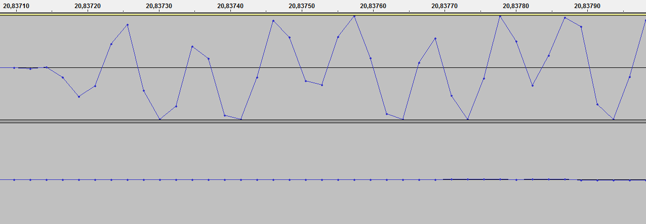**a)**

|  |  |  |  |  |  |  |  |  |  |  |  |
| --- | --- | --- | --- | --- | --- | --- | --- | --- | --- | --- | --- |
|  |  |  |  |  |  |  |  |  |  |  |  |
|  |  |  |  |  |  |  |  |  |  |  |  |
|  |  |  |  |  |  |  |  |  |  |  |  |
|  |  |  |  |  |  |  |  |  |  |  |  |
|  |  |  |  |  |  |  |  |  |  |  |  |
|  |  |  |  |  |  |  |  |  |  |  |  |
|  |  |  |  |  |  |  |  |  |  |  |  |

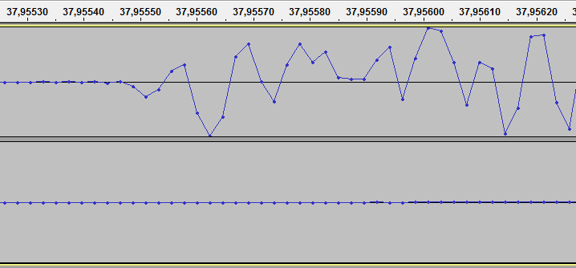**b)**

|  |  |  |  |  |  |  |  |  |  |  |  |
| --- | --- | --- | --- | --- | --- | --- | --- | --- | --- | --- | --- |
|  |  |  |  |  |  |  |  |  |  |  |  |
|  |  |  |  |  |  |  |  |  |  |  |  |
|  |  |  |  |  |  |  |  |  |  |  |  |
|  |  |  |  |  |  |  |  |  |  |  |  |
|  |  |  |  |  |  |  |  |  |  |  |  |
|  |  |  |  |  |  |  |  |  |  |  |  |
|  |  |  |  |  |  |  |  |  |  |  |  |